 | Student Name _______________________  Eastern Goldfields College  Unit 3 Essential Mathematics 2016  Mental Skills Test 1
 | Time: 10 minutes Total Marks: 50 marks
CALCULATORS NOT ALLOWED
1. A rectangle has a perimeter of 18cm. State a possible width and length. | 9. 45cm³ = ml
2. Calculate the area:  15m  10m | 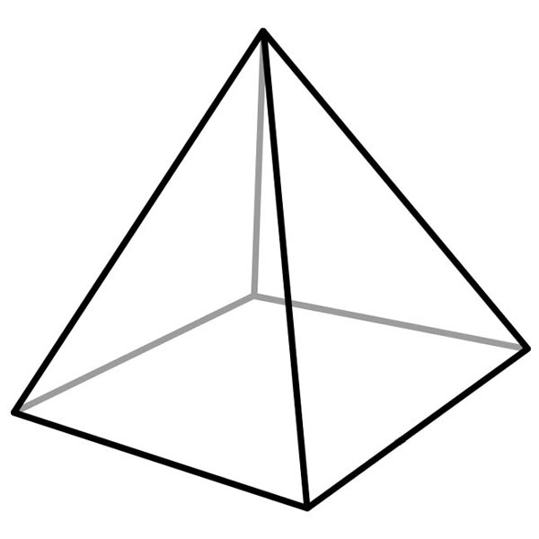  10. Find the volume:  3cm  3cm  2cm
3. 5cm² = mm² | 11. What is the capacity of the cube?  10cm  10cm  10cm
4. Name an area in ‘real life’ measured in m². | 12. Surface area of a cube with side length 5cm
5. 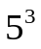 | 13. What units would you use to measure the capacity of a rainwater tank?
6. How many millilitres in 1 kilolitre? | 14. Each shape is made up of 5 cubes. Which has the greatest surface area?
7. Find the area:  7cm  6cm  11cm | 15. How much fencing is needed to completely fence in the paddock?.  70m  30m  Give answer in km  30m  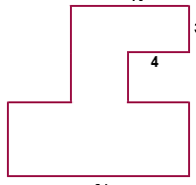  100m  100m  30m
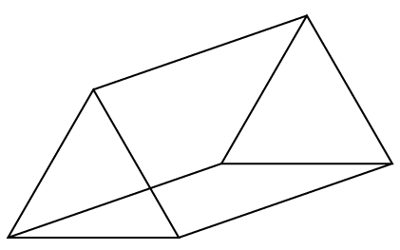
8. Name this shape.

